Background of the Project

Operational efficiency of business is vital for the success of an enterprise. In today’s competitive environment organizations are required to reduce their overheads while not comprising with the quality of services offered to the customer. Office automation or paperless offices are the buzzwords in business establishments. Computers now are taking over the manual systems which involve more human interaction.

In final year some companies visited our college for recruitment and we came across their selection procedure which was manual and cumbersome. Hence we felt there is scope for an online recruitment system. Our system not only makes the selection procedure customized but also reduces paperwork and time consumption. Our project makes test evaluation easy and unbiased which is what an organization seeks in a selection procedure.

Online Recruitment System coupled with support applications deployed on the system is used for organization to make the task of providing quick and better quality services to everyone. The present scope of the application is limited to online testing only. However, the design should be scalable to integrate online course module at a later stage seamlessly.

Objectives of the Project.

- To design an application for an organization using manual examination procedure for recruiting people.

- Application when deployed will provide the following type of services to the company:

  - Candidate enrollment in the company.
  - Authentication of each user or administrator be logging him into the system.
  - Provides interface to candidate to select post for examination
according to his eligibility i.e. qualification, experience etc.
  - Conducting the test and its evaluation.
  - Allows the administrator to specify the test pattern, time allotted to the test.
  - Allows the administrator to decide the tests to be conducted for the selection for a particular post.
  - Facility for creation of courses, tests and questions.
  - Editing existing Test/Question/Category/Post.
  - Maintaining a log for tracking error and debugging.
  - Generation of result and display of result according to the percentage for a particular post
  - Display of the result details of each candidate for a particular post.
  - Allows the admin to select the desired candidates and view the selected candidates
  - Creating new or modifying existing User/Admin profiles.

Scope

Online Recruitment System using Java and Servlet technology for conducting exam for the purpose recruiting eligible candidates thus reducing the manual work and labor involvement to some extent by maintaining candidates information, Result, user enrollment, authentication of the user, etc.
The proposed system is a Web-Based System for internal use of the organization. The scope of existing system is very limited due to the security limitations and failure of the system in case of a crash.

System scope:

- Existing system is limited to private network such as LAN.

- The proposed system platform is limited to Windows and can’t operate on any other platform such as Linux or Solaris.

- The system can only validate a person by his/her password and name and nothing else.

- System can validate duplicate requests by checking the present sessions but can’t validate false requests send by other user.

- System depends on oracle for its database and cannot function without setting up oracle database with all the necessary tables and functions.

- The questions are selected randomly from the question bank and same questions will repeat in consecutive tests.

- System merely allows selecting candidates but doesn’t have facility to inform them about their selection through email or by letter printing.

- The performance of the system is not tested on overloading conditions with many users accessing the system and the number of users with which it can perform efficiently is unknown.

- The application is based on the questions of purely text oriented and does not include any multimedia images, audio or video file.

- There is security of the user/admin passwords, database account password and super admin password is very low as none of the passwords are encrypted just dumped into the file or database.

- The application does not support for subjective type of questions and essay type of answers and only support objective type of questions.

- The system can’t handle network failures such as network overloading due to concurrent requests, failure of the server, user or server unreachable etc.

- No crash recovery is provided by the system and the system just eliminates all the operations performed before the crash which are error prone.

- The system can’t specify the number of vacancies available for a particular post and manage them but only restricts to the post which are to be filled.

- Concurrent access to the database by two or more administrators is permitted but any contradictory operation performed by the administrators may lead the system to be in error prone state or result in a failure.

- System can only inform about the failure to the user but not able to recover from the failure.

Tools and Technology Used

(Server Side)

- Java Servlet:-

Servlet are generic extension to java-enabled server. Their most common use is to extend Web servers, providing a very secure, portable, and easy-to-use replacement of CGI. A Servlet is a dynamically loaded module that services request from a web server. It runs entirely inside the Java Virtual Machine.

Reasons for using Java Servlet:

- Efficiency
- Persistency
- Portability
- Robustness
- Extensibility
- Security

- Apache Tomcat Web Server(Windows version)
Tomcat is a free Java Web Server that is used to run J2EE application run and can handle requests for HTML, Jsp Servlet. A Servlet doesn’t have a main method therefore it is totally under the control of a container i.e. Tomcat

- Java Server Pages :-

A Java Server Page (JSP) is a new way to use Servlet. JSP is a text-based Document that describes how to process a request to create a response. JSP is a simple, yet powerful technology for creating and maintaining dynamic-content web pages.
The JSP Architecture enables web page designers to concentrate on layout, and web application designers on programming, with minimal concern about impacting each other’s work.

Reasons for using JSP:

- Separation of dynamic and static content.
- Support for Scripting tags.
- Write once, run anywhere.
- High Quality tool support.
- Platform Independence.
- Power of Server Side Java.
- Reuse of Components and tags.
- Separating Content Generation from Presentation.

(Client Side)

- Java Script and HTML:-

JavaScript can be interpreted within a browser. JavaScript could be used to perform some client-side tasks as form validation and dynamic page content creation.
HTML is a set of special codes that can be embedded in text to add formatting and linking information.HTML is specified as TAG in a HTML document. HTML is used to develop web pages. HTML is language interpreted by the browser. Web pages are also known as HTML documents

Reasons for using Java script:

- Object Based.
- Cross Platform
- Loosely typed
- Security
- Multi use Language.
Introduction

The Online Recruitment System is a private network based system running on local area network. The System is designed against the manual recruiting processes used by some companies which involve lots of paper handling and manual entries while conducting an exam for recruitment. Such systems are very prone to errors. Whereas our Online Recruitment System is a fully automated system which requires very little human involvement and is user friendly and practically require no training as such they were trained on other details.
The application handles and manages all the detailed records of both administrators and the candidates appearing for the exam. Our System also enables the admin to view the result of the performed tests which can be sorted out according to the fields (such as marks, category, Users etc.) desired by the test taker. The test has purely objective types of questions such as Multiple Choice, Multiple Answer or True and false.
The operation of our system is divided basically into two parts i.e.-Administration & User part. In the administrator part the admin creates new questions for the test to happen under some category (course) for a particular post. He then defines a Test pattern for the test (which may include total no of questions, min. passing score, Time for test, Back scrolling etc.) which user appears. In the User part user has very limited access rights and appears for the exam of the desired post according to the conditions as set by the admin.
New user who is willing to give test has to first input his biodata in a predefined format to the system. According to specific entries system decides whether they are eligible candidate or not. If eligible then the system displays the name of the courses he/she has to appear. If he has already appeared for the test then user is not allowed to apply for that post. Users then selects the test to give, a test description with the warning appears before starting the test. On completion of all the tests users is given a vote of thanks and his Exam data are saved into the database. Results are generated with this saved data but not shown to the users.
Various activities are performed during the working of project. These works can be classified under two category-admin activity & user activity.
Admin Activity includes things like:
- Creation of admin account which can be offline too.
- Add new course to the application.
- Add new post for which recruitment is performed and decide the courses for the test.
- Create new questions under earlier created course.
- Set new test pattern for the test.
- Publish the posts for which the exams are to be conducted.
- Edit or delete existing test/Questions/Course.
- Result view and list users according to that.
- Select the appropriate candidates from the result and view selected candidates.
- View log for error tracking.
User activity includes things like:
- User registration (is mandatory before the commencement of the test).
- User logging into the system.
- Selection of the post to apply for.
- Selection of test of the course to appear for that post.
- Appear for the test.
- Continue till all the tests for the post are attempted.

Need for Online Recruitment System

- Existing recruitment procedure involves lots of time in taking the test for each candidate and manipulating the result which can be reduced.
- The paper handling involved in the procedure is tremendous with test papers, answer sheets, reports and resumes which can be eliminated.
- The effort and manual work involved in the present system is great and many employees are involved in the procedure which can be reduced thus reducing the total cost for the recruitment procedure.
- It is not possible to examine and pay attention to each candidate individually.
- A lots of manual mistakes may be made while correcting the tests and calculating the result manually which can be avoided.
- In a country like India with unemployment being the major problem large no of candidates apply for a post and it becomes a great overhead in sorting the ones eligible for interview which can be automated.
- There are repetitions, mistakes in the test and even leakage of the test papers.
- It becomes easy of the candidates to copy or discuss the answers if all of them have the same test paper.
- If the number of candidates applying is more than predicted then a lot of overhead is involved on the employees and they may skip the rest of the candidates of which some may be eligible and talented.
- The manager has to go through pile of resumes one by one which wastes time and energy which can be saved by quick and dynamic view of biodata.
- A sorted result has to be prepared may be by the percentage and if the manager wants to see the details of the test or of Bio-data then a he has to search for the document of particular candidate from the file which can be avoided by presenting the result, details of the candidates which can be sorted dynamically reducing the work load.
Requirement Analysis

(Based on a hypothetical company)

Understanding System in discussion with the client

Studying Organization: The System is to be designed to support the organization undertaking manual test for recruitment which is error prone, require more manpower, over head of paper handling and consumes lot of time. The system is to be designed to automate the recruitment procedure of conducting the test.

Objectives:
- To ease the process of recruiting by shifting from manual process to automated process.
- Automatic result generation and a sorted view of the result.
- More efficiency and accuracy in result evaluation.

Activities and Procedures :( User)

- Getting profile/bio data of users.

- Getting the post name for which user came to give the exam.

- Getting related subject/course for respective post.

- Selecting course according to his post/experience.

- Inform the user about the test procedure, patterns, rules, test warnings of commencing test.

- User should attempt all the courses for a particular post.
Activities and Procedure :( Administrator)

- Authenticate person in charge.

- Create a course/category/subject.

- Create a post for which test is to be conducted for recruitment.

- Decide the test format (e.g. time bound, total no of questions, back scrolling etc.) to be publish for a particular position.

- Add questions of different types (includes multiple Choice, multiple Answers of true/false).

- Can edit/delete course/question/test format.

- Decide the post to publish to conduct tests.

- Can view over all result after the test for particular post and particular user.

- Decide and select appropriate candidates according to their performance.

Rules and Standards of the organization:

- Test will be conducted on a group of candidates.

- A user once appeared for a test can re appear for the same test only after completion a time period of six months.

- Result is not shown to users and only accessed by administrators.

- Test is carried out only for single post at a particular moment.

- Maximum users at a time should not be more than 50 and minimum should not be less than 5 in order to manage the exam efficiently.

- Users are informed about the results through email.

- List of selected students will be finalized by the authority of the company.

- Candidates who try to cheat will be exempted from the examination.

- The correct answer of a question will be final and can be modified without any prior information to the candidates.

- The qualification, experience and the preferred aggregate percent in a test is decided by the company.

- New admin profile can be created only by super admin.

- User can leave a test anytime whether on completion or before completion of the allotted time.

Interface: (Users)

- Time is always conveyed to the users during the test.
- Users can access previous questions and can change its answers.
- User can check whether all the questions are attempted.

Interface: (Admin)

- Admin can easily select questions for a particular course.
- Admin should easily view results according to different constraints (like post, categories, marks, users etc.).
- Admin can access and remove user profile.
- Admin can view all users appearing for the test.
- Admin can view all the candidates already selected for interview.
- Admin can view the log after the exam is conducted for failures.

Internal Agent
Administrator- Administrator is a legal employee of the organization who is responsible to conduct test. Super administrator is the head of all and has all the access rights of the system.

External Agent
User- User is the candidate applying for a particular post and appears for the corresponding test.

Special Requirements:

- A category/course may have sub-category (e.g. Networking can have Network layer, Transport layer etc.).

- Authentication is based according to their profile.

- Access to previous or past records.

- Questions shown to each user should be different from each other.

- Company can assign priorities or minimum marks required for each category in the post according to their changing requirements.

- A course may be included in one or more posts for recruitment as per requirements of the company.

Identification of Existing Problems and constraints

- Secure access to the result of the exam is required.

- A question may get repeated in a test as questions are selected from a question bank randomly.

- High security is required for running application in private network.

- A question of one course may appear to candidate appearing for another course.

- User may change time from HTML source by initializing timer counter in the HTML source code.

- After recovering from the crash, system must retain its original state.

- A single question may repeat many times in consecutive exams while some questions may not appear at all.

- The test may not be submitted automatically after time out.

- The user can take his own time in between the two tests for a particular post

- The user may request the server from the previous tests or webpage’s thus
trying to attempt an invalid access to the system.

Findings with the client

- The system is designed to run only on private network with limited security features.

- Admin can only view the result but cannot modify it, hence result is read-only.

- The time shown to user is always reflected with the server periodically, therefore there is no chance of changing time at client side.

- As the questions are selected randomly there is very little chance that some questions remain unselected.

- If the system crashes during the test, user is allowed to reappear for the entire exam.

- If the user submits the test even after time out, then all his answers will be discarded and test will automatically be submitted.

- Different tests on various courses are used for recruitment for a particular post.

- The user will be allocated a time of 2-5 minutes in between two tests and the total time allocated to user is the sum of the time allocated to each test and 2-5 min break in between each test.

- All the user requests will be checked if the session is valid and if the request is from the current webpage before the request is accepted.

System Requirement Review

Existing system:

- Existing system involves manual recruitment procedure.

- Requires a lot of time to sort the user details and test result to provide a desired view.

- The test pattern cannot be changed randomly and required a lot of effort.

- A large amount of time and effort is required for deciding, publishing the copies of the test and correcting the papers to generate result.

- Earlier user selection for a particular post required a lot of time.

- It provides identical questions to all candidates appearing for the exam.

The proposed solution, Online Recruitment System, meets the following requirements.

Proposed system:

- Proposed system operates only on private network based system running on LAN.

- The system provides a facility to directly apply for a particular post by selecting appropriate post and attempt the exam of the selected post.

- The proposed system platform is limited to Windows.

- All the data is stored in a centralized database hence efficient access to all the users.

- Admin can customize the test pattern and decide the tests to be published for an exam for a particular post.

- Random questions are selected to each user during the exam.

- Admin can easily select the candidate by viewing the result of individual candidate for a particular post.

Benefits of the System:-

- The system allows the company to customize the test pattern and the create courses according to their needs for a particular post; specify their minimum eligibility requirements for each post and the minimum passing criteria for each course and for overall exam.

- The not only manipulates the result but also sorts the result according to their requirements thus decreasing the manual overhead.

- System creates different connections and different variable instances for different users and maintains a session for each user thus providing adequate privacy, security to the users.

- This system uses client side validation before sending request to the server which increases the system performance.

- The system provides the log of the entire operations carried during the examination for detecting failures in the system.

- All the candidates appearing for recruitment exam will receive different questions even if their courses are same (this facility is also not available in the existing system).

- Questions in this system are of different types (multiple answer, single answer, true and false), by means of which admin can choose the type while preparing the test for candidate.

- Admin decides pattern of test for each course i.e. questions are of random/same type, time limit, back scrolling allowed/disabled.

- Questions for the tests are generated automatically at run time hence no one (not even the examiner/administrator) can predict the exact questions which would appear in a particular test.

- The system performs the necessary functions required for distributed computing such as concurrent access, request validations, concurrent processing for different users etc.

- For each an every user a new connection is established from the connection pool which keeps a record of total number of connections created.

- System is secure from requests replaying or regenerating previous requests as the server validates each request from the user with the current session entries.

- The bio-data of any desired candidate can be view instantly by the administrator for the selection/interview call to the candidate.

- All the rules and regulations of the organization is easily followed by making appropriate settings in the system such as candidate can’t reappear the exam before 6 months, super admin only can make changes in admin profiles etc.

- Admin can decide at runtime which of the courses/tests the candidate should attempt for a particular post and publishes them so that the user can only have access to the tests to be attempted rather than all the tests present.

Requirement Specification Document (RSD)

Abstract: The proposed system is a Browser-Based System for internal organization use of implementing Online Recruitment System. The application is limited to online examination and provide results for a particular post. However, the design should be scalable to integrate online course module at a later stage seamlessly.

1. Introduction

1.1 Purpose:
The purpose of this document is to describe the external requirements
for an online Recruitment System. It also describes the interfaces for the
system.

1.2 Scope: This document is the only one that describes the requirements of the system. The developer is responsible for any clarifications with the client regarding requirements, where necessary and he will not make any alteration without the permission of the client.

1.3 Developers Responsibilities Overview

The developers are responsible for
- Creation of the entire system according to the requirements of the client.
- Implementing validation and restrictions according to the needs of the client.
- Completion of the system as per the prescribed suggestions within a given time period.
- Installing the software on the clients’ hardware and creating a complete platform required for running of the system.
- Conducting any live demos and user training that might be needed for using the system.
- Submit project after completion with the user manual and a default super admin password to the authorized user.
- Notify authority or authorized users to about the limitations and possible failures of the system.
- On faults and defects informed by the client remove them from the system.

2 General Descriptions

2.1 Project Function Overview

In this application the admin can create a set of posts which are vacant and to be filled. For each post he decides the set of courses (subjects) for which the candidate should be examined before his selection. In each course he defines different test patterns and questions of various types. Questions are of 3 types namely- Multiple Choice, Multiple Answers and True/False. The super administrator who has authorized access to the core functionality of the system can add new administrators if required.
The system is to take the examination for selecting appropriate candidates for a particular post. A Test pattern is predefined before conduction the exam which limits the users of the system under some pre-decided interfaces. The result of the test is to be stored in a centralized database which is later used by authorities for selecting the candidates for interview.

2.2 User Characteristics

The Primary users of the system will be authorized administrators of the company who is made responsible for conducting the Recruitment and setting the test patterns and questions; the secondary users are the candidates who appear for the exam.

2.3 General Constraints

The system is built upon a platform independent tool but it is highly recommended that system must be run under:

Pentium class computers using 600 MHZ processors or above,
Memory -128 MB RAM+
Network LAN and Switched Ethernet.
NIC speed 10/100 MBPS
Windows Operating System (98/NT/2000/XP)

For higher efficiency.

2.4 Major Benefits of the solution.

- The system is more efficient than the present manual system.
- System reduces a lot of paper handling and manual work.
- Facility to define new test pattern for every batch seeking the test.
- Random questions asked for each candidate at run time.
- Tracks invalid requests to the server by authenticating each request.
- It facilitates dynamic retrieval of data.
- Access Rights to the system according to the login information.
- Log table is readily available for error tracking.

2.5 Exclusions

- The system is based on objective type of questions and does not support subjective type of questions with essay type of answers.
- The application is based on questions of purely text type and does not include any multimedia images, audio or video files.
- High security features that restrict our system to be used only under private networks.
- The application is not platform independent restricted only to Windows.
- User can’t randomly access the test questions.
- Concurrent access to the database by two administrators can cause severe problems to the system.

2.5 Assumption

  - Initially there will be only one administrator to configure the system.
  - The users appearing for the test must be a fresh user or he should have registered with a company before six months.
  - The system is running on windows platform with java virtual machine, tomcat server installed and oracle database created.
  - All the database tables, triggers, functions and sequences are assumed to be created in the oracle database.
  - The Oracle instance must be started and Tomcat server should be deployed.

3. Specific Requirement

3.1 Functional Requirement

- Test setter must be able to decide upon the test pattern to conduct test
- Not all but only the name of the published course should be visible to user for selection.
- The interface and the time allotment should only be decided by the test setter.
- All Questions must be inherent in some category/course.
- Admin must be able to search Questions and tests from the database.
- The system must calculate the result from the test data it receives from individual users automatically.
- Questions visible to each user should be from other users.
- Questions can be picked both randomly of sequentially from the database.
- All the test data must be stored in the central database for access of history data.
- The system must maintain a record of selected candidates in its database.

3.1 Input Contents

User:
- Bio data of fresh candidates.
- Questions attempted and answers given by each individual user for each test.

Admin:
            - New administrators profile and password (restricted to super admin).
            - Requirement and description of the posts to be recruited.
            - Courses to be included in the post, the test pattern and
questions for the test.
            - Set of options for each question with its answer.
            - The tests to be published for the posts to be filled by the company.
            - Decides the candidates to be selected from the result and user details

3.2 Output Contents

- Profile of all the users registered.
- The result of all the candidates post wise, date wise.
- Result of each individual candidate in detail.
- List of all the administrators except the super admin.
- View all the candidates selected by the admin for each post.
- Log of the system recording the system activities.

3.3 External Interface Requirement

User Interface:

- A prototype must be developed for the GUI in order to get acquainted with the preceding of the system to the developers and coders.
- The system should prompt for every invalid input in order to guide the user.
- The user should be informed of rules and regulations before the exam.
- Only one or very few user commands are provided in order to restrict the user access to the system.
- The user interface should provide all the help required for the client in operating the system.

Security Requirements

The system must have a restricted access to Admin part (only the registered employee of the company can access the system). The database is not accessible to both administrators and candidates appearing for the test. The super admin has a default profile which can’t be deleted having an unrestricted access to the system

Acceptance

Before accepting the system by users a demonstration of the system must be given with min. of 50 questions and 4 courses for a particular post, the developer will have to show through test cases that all conditions are satisfied.

System Analysis

ANALYZING SYSTEM REQUIREMENTS W.R.T

- Security:
  - Deletion/Modification of profile is done only by super admin. No other administrator has access to these privileges.
  - In case of crash all further processes will be cancelled and the system automatically exits.
  - Servlet run on the server side inheriting security by the web server. Servlet can also take advantage of the Java Security manager.
  - Encryption of passwords should be done before storing them in database.
  - Every exception example I/O, SQL, Null Pointer etc is retained for crash recovery.

- Reliability:
- In case of the crash of the browser or the system during a test, no data should be lost; user is allowed to re appear for the test.
- All the user test information and inconsistent admin operations should be deleted.

- Performance:
    - System uses minimum number of connections with the data base. The same connection can be used if it is free or can be destroyed if not required.
    - Questions to be selected are decided at run time by using random function from the question bank.
    - The number of users is restricted by the system to a specific number so that system performance does not degrade due to over loading.
    - All the temporary variables allocated to the user should be flushed off, closing all the connections which will be allocated to new user thus maintaining the system performance.

- Error/Recovery:
    - System errors can be broadly classified into 3 types.
        - Connection Error.
        - Database Error
        - Session Error
System must stand against these errors in case of their occurrence. System must have a recovery process to regain it self in a state where it was previously.
    - Invalid inputs from the user should be trapped such as invalid birth date, email id, passwords etc and the user should be forced to re-enter the parameters again.
    - User should be informed of all types of system errors such as
              - Database is empty
              - No tests published by the admin
              - Insufficient questions for the test
    - Sending request to the server from an old/pervious webpage with the help of the browser should be denied.
    - Invalid user sessions should be trapped and requests should be rejected.

- Backup/Restore
  - System creates a temporary backup of the questions and answers given by user during a test which is used for result calculation.
  - System maintains a log of all the operations performed during the exam.
  - System creates a backup of the results of the candidates in order to recover data.

Develop Prototype:

Develop prototype to demonstrate the understanding of the user requirements and the functionality that will be provided in the proposed system.

Objectives of Prototype:
- Understanding of the existing system
- Functionality of the proposed system.
- Data to be maintained.
- Functions to be provided.
- Data entry screens to be provided.
- Inquiries and report to be provided.
- External interfaces to be provided.

The prototype is a throwaway and not an evolutionary. It is just developed for the above mentioned objectives.

Software and hardware requirement for developing prototype.

- A HTML editor (like Dream Weaver, Interdev).
- A desktop PC running GUI Operating System.
- Web browser.

High Level Design

Design Objectives

- Reliability: The user can reappear for the test in case respective test crashes in between. If reference errors occur in user connection or database connection then all the operation in queue are cancelled.

- Performance: A single connection can be used for all database access activities. Runtime allocation can be offered to store number of questions in the buffer for back traversing.

- User Interface: User should be guided while s/he is giving the input and only valid inputs will be accepted. Prompt an alert message to every illegal input or action. For better usability user should be provided all types of help for quick reference. Each and every action of user is tracked in the log which can be viewed by admin during the test.

- Storage: The storage of all records is done in database (which can be replicated to ensure reliability).

Design Directives

- The design should be modular, the software is logically partitioned into elements that perform specific functions and sub functions.
- The admin and user parts are designed separately.
- The design contains distinct representation of data (database), architecture (system architecture), Interfaces (GUI etc.) and components (functions and procedures).

Identifying System Components

(Admin Part)

- Create category/course/subject.
- Create questions inherent in some category.
- Create test pattern with suitable constraints.
- Create/Edit Post (No deletion of posts are done).
- Create new admin profile by super admin.
- Search questions in some existing category.
- Edit/Delete category/question/test.
- Edit/delete user profile.
- Publish a test for a particular post for which test is conducted.
- View a test result.
- Select appropriate candidate from the result.
- View of the selected candidates.
- Log view.

(User Part)

- Create user profile.
- Authenticate users of the system.
- Accept the post selected by the user.
- Accept test course.
- Pre requisites for taking test (Test rules).
- Present test and review answers.
- Generate result.

Error Messages

(User Side).

- An alert message is shown when user submits a form which has one or more fields left blank or unchecked.

- Prompts an alert message for invalid email id, date or an entry field.

- Prompt an alert message for invalid login id and password entered while login.

- Prompts an invalid message when the user tries to select the post for which he is not eligible.
- Prompt an alert message in selecting course if the tests are not published by admin in that post.

- Prompt invalid category id or test id if the max questions in database are less than the max question fed in setting a pattern for a test.

- Prompt an alert message if no course is selected while taking the test.

- Prompt an alert message if user has not got the required qualification & experience for the post for which test is conducted.

- Prompt an alert message if user leaves the test in between and warns him about the failure in selection for that post.

(Admin side)

- Prompt an alert message for all invalid or unfilled forms.

- Prompt an alert message for all before deletion of category/test/profile.

- Prompt an alert message if no questions found in the category.

- Prompt an alert message if no user exists.

- Prompt an invalid message if admin tries to delete his own profile.

- Prompt an alert message if no category is defined under post.

- Prompt an alert message if no tests are published for a particular post.

- Prompt when admin tries to select a candidate who is already selected
for a particular post.

Definition of system Architecture w.r.t:-

- Data Access: - Connection pool class provides connection to database, queries are evaluated and result is produced in a result set using JDBC: ODBC connectivity.

- Communication: - Request is send by client to server and server responds accordingly. Servlet service methods like doGet and doPost are overridden to handle the request/response scenario. The class hierarchy is…

Generic Servlet

Http Servlet

HttpRequest/HttpResponse

- Audit:- A customized report generation from the Result is done i.e.
-Post wise
-User wise
-category wise

- User Interface: - The output stream of printWriter is used to build the HTML page. The pages are linked by either (Submit hyperlinks or by sendRedirect () method which redirects the page).

Low level Design

Identifying Programs units:

(Admin Part)
- Creation/Modification of new Admin profile.
- Creation/Modification of new User profile.
- Set test pattern.
- Modification/Deletion of existing test.
- Creation of questions.
- Modification/Deletion of question.
- Addition/Creation of new course.
- Modification/Removal of existing category.
- Creation/Configuration of Post.
- Result Generation.
- Selection of appropriate candidate from the result for a post.

(User Part)
- User Authentication
- Selecting Post.
- Selecting category.
- Displaying test Rules and warning.
- Starting the test.
- Appearing a test.
- Review Answers
- Vote of thanks.

Specification of units at logical level

(Admin part)

- Creation/Modification of new Admin profile.

Description: This functionality will facilitate the admin to create a new admin profile. Only Super admin of the system has got this privilege. No other admin has got this right.

Basic Flow: A registration form is displayed for admin to create a new admin profile. When all the fields are correctly entered and submitted a new admin profile is created and all values are updated in the database. A combo box displays the list of all existing admin profile where the super admin can pick any one profile for modification or removal. No other admin is authorized to perform such operations.

Alternative flow: If the user does not enter any information in the text box or does not select anything from the drop down list, system will prompt the user to enter the text. System will not undertake any action unless the user specifies the proper text.

- Creation/Modification of new User profile

Description: This functionality will facilitate the admin to create a new user profile or modify the existing user profile. All admin of the system has got this privilege.
Basic flow: A form is displayed for admin to create a new user profile. When all fields are filled correctly and the form is submitted a new user profile is created in the database. A combo box displays the list of all existing users, admin can select any user and can either modify or can remove him/her from the system. When a user profile is deleted all data about the profile is lost.

Alternative flow: If the user does not enter any information in the text box or does not select anything from the drop down list, system will prompt the user to enter the text. System will not undertake any action unless the user specifies the proper text.

- Setting test pattern

Description: This functionality provides admin to set a test format to conduct a test. The pattern includes things like no of questions, passing score, question type, time allotted etc.

Basic Flow: A JSP for, is displayed which actually accepts the input from admin for setting the test. A test is created under some category. All inputs are given and values are pushed into database.

Alternative flow: If the user does not enter any information in the text box or does not select anything from the drop down list, system will prompt the user to enter the text. System will not undertake any action unless the user specifies the proper text.

- Modification/Deletion of test:

Description: This functionality provides an admin to correct his previous correction or any new modification. S/he may also delete the test if s/he wants to.

Basic Flow: A JSP page displays all the tests. All the tests are inherent in some category are displayed when admin selects a category from the category list and presses go. The test can now be picked either for modifying or for deletion.

Alternative flow: If the user does not enter any information in the text box or does not select anything from the drop down list, system will prompt the user to enter the text. System will not undertake any action unless the user specifies the proper text.

- Creation of questions

Description: Questions can be of any one of three types namely Multiple choice, Multiple Answers or True/False. This functionality provides admin to select a type for creating new questions.

Basic Flow: Admin selects among multiple choice, Multiple Answers or True/False to create a new questions. According to the choice of admin respective HTML page is displayed for creating new question. According to the choice selected by the admin and the respective fields are filled while all possible answers are written into answer fields. The correct answers are checked and values are a\saved into database. Questions are saved into different table while answers are saved into Answers table.

Alternative flow: If the user does not enter any information in the text box or does not select anything from the drop down list, system will prompt the user to enter the text. System will not undertake any action unless the user specifies the proper text.

- Modification/Deletion of question

Description: This functionality provides admin to delete or to modify existing questions. When a question is deleted corresponding answers are also deleted from the answers table.
Basic flow: A JSP page displayed showing a list of all categories in the system. A category is selected and go button is pressed then all the questions in that category is displayed from where admin can pick questions for modification/Deletion.
Alternative flow: If the user does not enter any information in the text box or does not select anything from the drop down list, system will prompt the user to enter the text. System will not undertake any action unless the user specifies the proper text.

- Addition/Creation of new course

Description: This functionality provides admin to add a new course to the system. All the questions are then created under this category.
Basic flow: An Html page is displayed to accept the inputs from user. Unique category id is a sequence in DB therefore admin does not have to worry about category code. When the from is submitted a new category is created and saved into database.

Alternative flow: If the user does not enter any information in the text box or does not select anything from the drop down list, system will prompt the user to enter the text. System will not undertake any action unless the user specifies the proper text.

- Modification/Removal of existing category

Description: This functionality provides admin either to modify the name, description of category or remove an existing category from the system. When a category is removed all the questions answers and tests associated with that category is also removed.

Basic Flow: A JSP page displays the entire existing category in combo box for admin to select among category. Category can be modified or deleted by choosing on the option of deleting or editing.

Alternative flow: If the user does not enter any information in the text box or does not select anything from the drop down list, system will prompt the user to enter the text. System will not undertake any action unless the user specifies the proper text.

- Creation and configuration of Post:

Description: This functionality provides admin to create a new post in the organization. These posts are associated with some categories in which tests are taken. Candidate associated with that post has to appear for all the categories included in that post.

Basic flow: A form is displayed and the admin fills the field to create a new post. Experienced is also included in post. Categories are selected from the list and are added to be included in that post. These values are then saved in the database in post table.

Alternative flow: If the user does not enter any information in the text box or does not select anything from the drop down list, system will prompt the user to enter the text. System will not undertake any action unless the user specifies the proper text.

- Result Generation

Description: This functionality enables admin to view the report/result of the conducted tests. The result is generated according to post and candidates who have appeared for the tests.

Basic flow: When clicks on the result option an option page is displayed to choose whether admin chooses result by post or by users on some post. The result is a JSP page showing the result in list view. Admin can select appropriate candidate view his performance in detail for a particular post and select him for interview.

Alternative flow: If the user does not enter any information in the text box or does not select anything from the drop down list, system will prompt the user to enter the text. System will not undertake any action unless the user specifies the proper text.

(User Part)

- User Authentication

Description: This functionality provides users to log into the system.

Basic flow: An Html page is displayed to the user where s/he enters her/him login name and password. The system then verifies it from the database and if successful forwards the user a page where s/he can choose the post to apply.

Alternative flow: If the user does not enter any information in the text box or does not select anything from the drop down list, system will prompt the user to enter the text. System will not undertake any action unless the user specifies the proper text.

- Selecting Post

Description: This functionality provides users to select the post displayed to the users for which the company wants to recruit. User can only select one of the post to apply at a time..

Basic Flow: If the qualification of the user and his experience desired by the company satisfies the company requirement then the user is allowed to apply for that post. Also if the user had already attempted the exam for the same post before 6 months then the request of the user is denied
.
Alternative flow: If the user does not select any option then the system prompts to select a particular option i.e. post, if no post is available then user may log out the system.

- Selecting category

Description: This functionality provides users to select among the category displayed to the users who are appearing for the test. Appearing for all the displayed categories is compulsory. But its on user to decide which course is appearing for first and which for last.

Basic Flow: A Servlet is called which gets the post of the user for which s/he is appearing. All the categories in that post are then displayed. If a user have already attempted for a course he is not able to re appear for that course again. Only the published tests can be available for test.
Alternative flow: If the user does not select any option then the system prompts to select a particular option i.e. category.

- Displaying test Rules and warning

Description: This functionality provides user the detail description of the test such as total no of questions, minimum passing score, and time allotted for the test etc.

Basic flow: A Servlet is called that retrieves the description of category for which user is appearing for the test and displays it on his/her screen. The Servlet also displays the test patterns such as total no of questions, minimum passing score, if back scrolling is allowed or not, time of the test etc. If users accept the rules his test starts and another Servlet is called.

- Starting the test.

Description: This functionality provides users to view the questions appearing on their screen and select an appropriate answer for the same. Depending on the test pattern user may see his previous questions and correct his last answers.
Basic flow: A Servlet is called that gets questions from the database. The questions are picked randomly from database using a random function. When user selects an answer and press next button his data is saved into database. These data is then compared with the correct answer and the result is generated accordingly. A time is always displayed on the test page. If user answers a question after the completion of the allotted time then his answers are discarded and result is generated with his previous answers. If user clicks on the back button the system checks whether back scrolling is allowed or not if yes then last visited question is displayed for user to correct his last answer. User can submit his test any time in between the allotted time.

- Review Answers

Description: This functionality provides user a page displaying the summary of the test. His all attempted and not attempted questions are displayed.

Basic flow: System gets all the questions he attempted and not attempted during the test from the database and displays it on the user machine.

- Vote of thanks.

Description: This functionality displays user a vote of thanks. But internally the system does its works of result evaluation.

Basic flow: The system calculates the percentage of user for each course and it then store these result of individual category in a nested table in database. These data can be used to generate result by admin in later phase.

Data Flow Diagrams

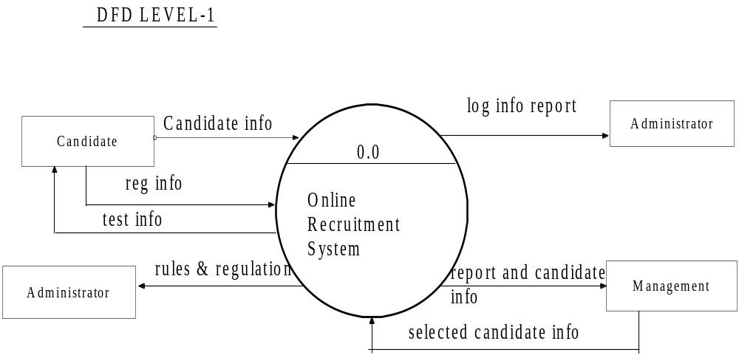
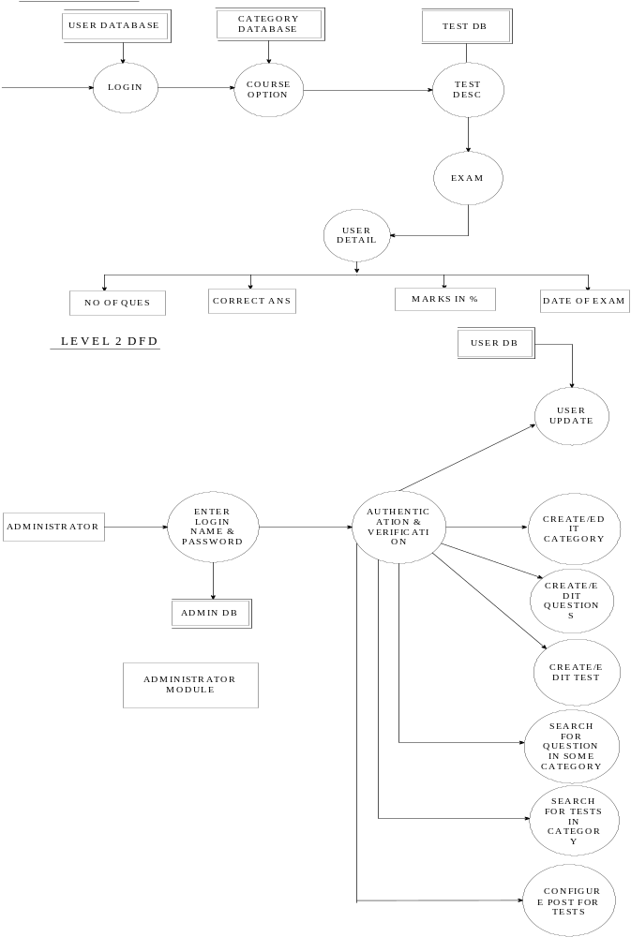

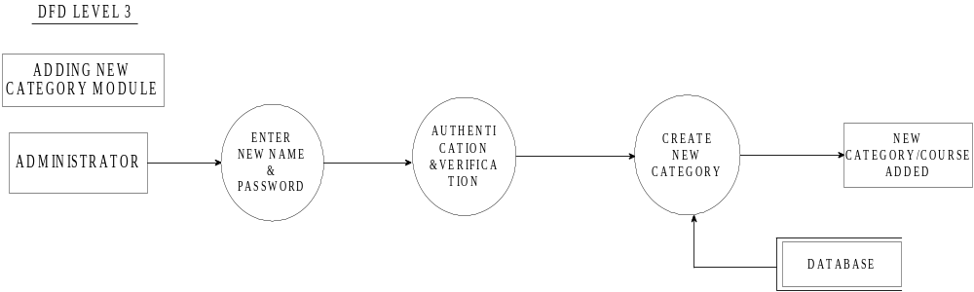

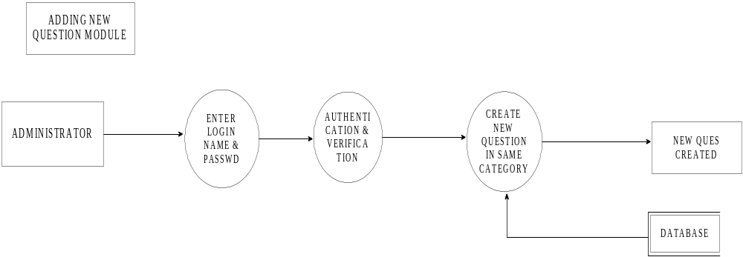

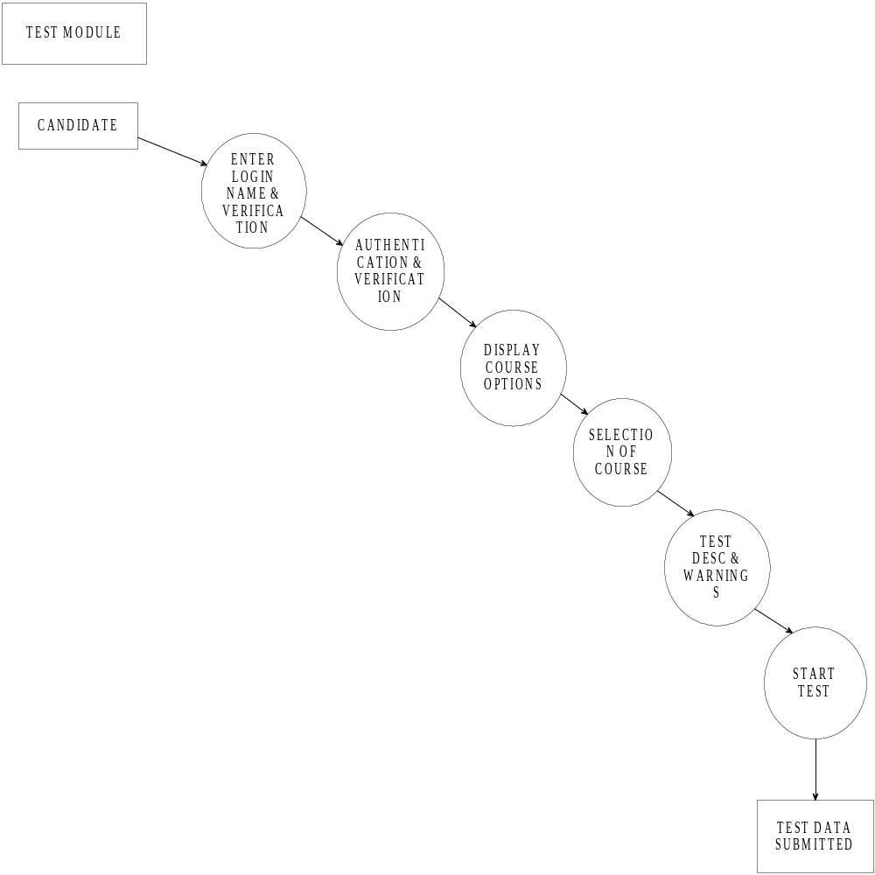

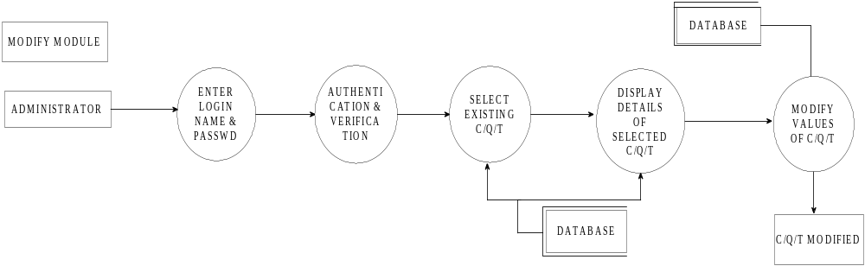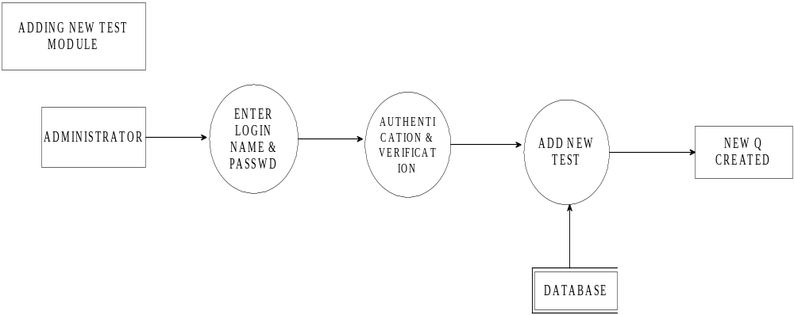
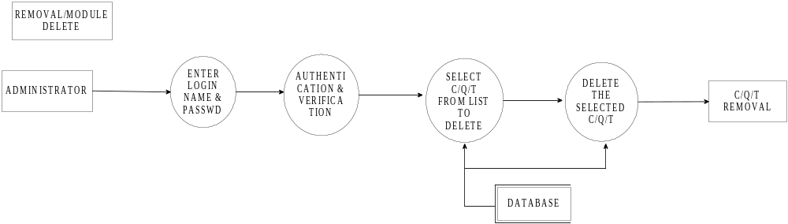

ER-Diagram

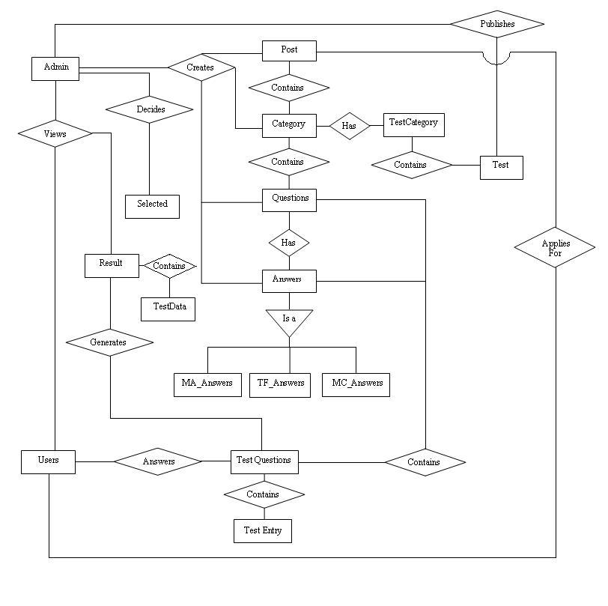

Working model of the system

The system is a fully automated system -
The operation of our system is basically divided into two parts i.e. Administrator & User. Each part performs same activity based on their privileges.
These activities can be classified as
:: Admin Activity & User Activity

Admin Activity:
An admin account can be created which can take place offline too. New course can be added to application. New questions can be created under earlier course. Admin can set new test pattern for the test. Admin can create a post attribute containing courses to be attempted and tests for the courses are published for a particular post. Result can be viewed by the administrator and can select appropriate candidates for a particular post.

User Activity:
User registration is done before commencement of the test. User then logs into the system and selects the post for which he wants to apply for and then selects respective course after which he appears for the test.

Same idea can be seen through following system architecture.

SYSTEM ARCHITECTURE

The System is based upon Microsoft’s DNA (distributed Network Architecture) and has three layers. The 3 tiers Architecture can be shown as

Conceptual Design | Software Tools
User Presentation Layer  Business logic Layer  Data Service Layer | Html  &  Servlet Pages  Java Classes  (JDBC)  Oracle 8i  Date Base

User Presentation Layer: It contains the pure HTML and JSP Pages, which in turn send and receives the request and response from the Business Logic Layer.

Online Recruitment System
Business logic Layer: The actual logic of retrieving and storing data into database is done in this layer.

Database Service Layer: It is any DBMS like Oracle8i and stores the data.
System Design: The system is designed based on Model-View-Controller (MVC).

Pattern. The MVC design divides an application into three components areas.

- MODEL: The Model is system application’s business logic and data.

- VIEW: The View is the part of application that displays the information to the user.

- CONTROLLER: The Controller is that part of the application that manages user input.

Controller
(Java Classes)
View
(SERVLET, Html)

Model
(Java Beans)

Sql Server
Database

Project Implementation

The method of parallel implementation will be followed when implementing the system.
Implementation phase involves the following steps:
1. Installing the system
2. Converting existing data
3. Training the users

Training was provided to the user till they are comfortable with the system and confident to use the Online Recruitment System. Since the application is user friendly and practically require no training as such they were trained on other details.

User Acceptance:-
The user acceptance was sought while designing the system itself .The user of the system was consulted before every phase and the system has been designed accordingly.

The design of the input screens was developed and made as user friendly as possible with all details on the screen itself which would also help a novice user or a new comer .After careful completion of each module, the user was consulted .After careful testing phase, the user was again consulted and the system was implemented to the complete satisfaction of the user.

The designing was done on the through study of requirements. Software
Development Company was inspected properly before implementation of this
Software .Every weak there was meeting with the company and accordingly the
Changes were done.

System Test Plan

- Test if no Input name and password is supplied by the user.
- Test if no tests are published by the admin, even though the user to appears for the test.
- Test if the category already appeared by the user is disabled.
- Test if no category is entered by the user.
- Test the system behavior if insufficient questions are present in the database of that category/type.
- Test the system response if an old webpage is invoked.
- Test the performance of the system whether if satisfies the parameters such as scrolling, time, type of question and test.
- Test the effect if the user changes the system time of his system or of the html page on the test timer.
- Test the system output when the random number generated is not present in the domain of the questions to be selected.
- Test if the user answers after the time limit check if his answer is considered.
- Test the system behavior if the random number function returns a repeated number.
- Test the system performance if the user continuously traverses backward and then forward with changing his previous options.
- Test the response if the maximum questions allowed in the test are reached.
- Test if the user takes a long break in between the two tests of categories for a post.
- Test whether the system considers the all categories whether attempted else not to calculate the result.
- Test if the user inserts the same name and password present previously in the user data while registration.
- Test the systems action when the user already appeared for the particular post tries to reappear before 6 months.
- Test the system performance if the user logs off and a different user logs in immediately.
- Test the system if the admin tries to delete/edit himself or the super admin at run time.
- Test the system behavior if the user tries to insert a question or a test in the category which does not exists.
- Test the system when the user tries to publish more than one test in a particular category.
- Test the systems response if the user tries to invoke a question or a test of a deleted category.
- Operate the system in a worst case and determine the number of user with which the system operates smoothly.
- Test the systems reliability by crashing the server, a user or the admin.
- Determine the systems response if the previous webpage is resubmitted to the server by the user.
- Test the system if two administrators try to update/create a category, test, question simultaneously.
- Test for the user trying to login into the system if another user has logged on the same user id.

Test Cases

-> The following tests are carried on Windows platform only.
-> The tests are carried out on a LAN with only two machines connected
to it (One acting as server and again both acting as the users).
-> No tests are carried out for recording the system resources usage for
each user and the total no of users that the system supports

UNIT TESTING

(1) Test Case/Scenario: No Input supplied by the user.

Criticality: Medium
Preconditions: None
Parameters to be recorded: Input parameters.
Expected Output: System prompts error message.

Actual Output: System prompts error message.
Test Status: Pass.

(2) Test Case/Scenario: Users starts the test with no tests published by the administrator.
Criticality: High
Preconditions: None.
Parameters to be recorded: Test Id and Publish.
Expected Output: System prompts appropriate message
Actual Output: System behaves as required.
Test Status: Pass.

(3) Test Case/Scenario: Test details such as timed, supports scrolling, Random/Sequential type of questions etc are considered.

Criticality: High
Preconditions: Test Id selected.
Parameters to be recorded: Time, Scrolling, Question Type and Test Type.
Expected Output: Test is to be carried out according to the specified parameters.
Actual Output: Test satisfies all the specified constraints.
Test Status: Pass.

(4) Test Case/Scenario: No category is selected for a test to begun.

Criticality: Medium
Preconditions: None.
Parameters to be recorded: Category Id
Expected Output: System should ask the user to select a category.
Actual Output: System prompts for category Id.
Test Status: Pass.

(5) Test Case/Scenario: Time displayed to the user is always valid.

Criticality: High
Preconditions: Time for the Test.
Parameters to be recorded: System Time, Test Time.
Expected Output: System should display the time remaining for the test.
Actual Output: System gives invalid time when operated at 12.00 am.
Test Status: Fails.

(6) Test Case/Scenario: Repetitions of the questions in the test.

Criticality: High
Preconditions: Question Id.
Parameters to be recorded: Previous Questions and current Question Id.
Expected Output: System automatically selects the next Question Id in case of repetitions.
Actual Output: System skips the repeated questions.
Test Status: Pass.

(7) Test Case/Scenario: Traversing through the questions back and forward in the test.

Criticality: High
Preconditions: All variables initialized.
Parameters to be recorded: Previous Questions, Current Question,
Loaded Question and Question Id.
Expected Output: System should efficiently traverse to and fro with valid questions displayed.
Actual Output: System satisfies the required output.
Test Status: Pass.

(8) Test Case/Scenario: Answers of the previous questions displayed while back traversing.

Criticality: Medium
Preconditions: Questions are attempted by the user.
Parameters to be recorded: Question Id, Previous Answers.
Expected Output: System should provide answers given by the user in the previous questions.
Actual Output: System behaves as per the requirement.
Test Status: Pass.

(9) Test Case/Scenario: Total categories to be attempted for a particular post are attempted by the user.

Criticality: Medium
Preconditions: Total categories to be attempted should be
known.
Parameters to be recorded: Category Id, Post Id, Total categories.
Expected Output: System should track the total categories attempted by the user for the post and ask the user to continue accordingly.
Actual Output: System continues to choose test till all tests
are attempted.
Test Status: Pass.

(10) Test Case/Scenario: User enters any rubbish input.

Criticality: Medium
Preconditions: User is logged into the system.
Parameters to be recorded: All user inputs.
Expected Output: System prompts appropriate message accordingly.
Actual Output: System demands re-entry of the
parameters.
Test Status: Pass.
Remarks: Checks such as valid email id,
Dates, passwords, names (strings),
Telephone no etc are performed.

(11) Test Case/Scenario: Deletion of a category.

Criticality: Medium
Preconditions: Categories are already created.
Parameters to be recorded: Category Id, Test Id, Questions.
Expected Output: System automatically deletes all the tests, questions and their answers on deletion of the category.
Actual Output: All corresponding test, question
and answers are deleted.
Test Status: Pass.

SYSTEM TESTING

(1) Test Case/Scenario: Max Questions for the test is more than available.

Criticality: High
Preconditions: None.
Parameters to be recorded: Question Id, Max Questions, Total Questions.
Expected Output: System prompts appropriate message accordingly.
Actual Output: System behaves as required.
Test Status: Pass.

(2) Test Case/Scenario: Changes in the User Id or Test Id made by using the previous saved Test Page.

Criticality: High
Preconditions: User must be authenticated before the test.
Parameters to be recorded: User Id and Test Id.
Expected Output: User Id and test Id should remain unchanged.
Actual Output: User and Test Id stored and retrieved from session without any change.
Test Status: Pass.

(3) Test Case/Scenario: No question is present in the database having the id equal to the random number generated.

Criticality: High
Preconditions: Random number.
Parameters to be recorded: Random number, Question Id.
Expected Output: System should select the random number in the domain of excepted questions and acquire Question Id.
Actual Output: System behaves as required.
Test Status: Pass.

(4) Test Case/Scenario: User logs off from the system and new user is ready to login.

Criticality: High
Preconditions: User is logged into the system.
Parameters to be recorded: None.
Expected Output: System destroys all the connections and temporary variables used in the system before log off.
Actual Output: All variables are initialized and connections are closed.
Test Status: Pass.

(5) Test Case/Scenario: Admin tries to delete/edit himself or other admin at runtime.

Criticality: High
Preconditions: Admin must be registered in the system.
Parameters to be recorded: Admin Id.
Expected Output: System prompts if any admin tries to create, delete or edit any admin except the Super Admin.
Actual Output: System prompts that all admin profile
Operations can be carried out only by the
Super Admin.
Test Status: Pass.
Remarks: Super admin can’t be created or deleted,
only edited.

(6) Test Case/Scenario: No category exists while adding a new Question or a new test.

Criticality: High
Preconditions: None.
Parameters to be recorded: Category Id.
Expected Output: System prompts absence of category message canceling the operation.
Actual Output: System behaves as per requirement.
Test Status: Pass.

(7) Test Case/Scenario: Number of users the system can accommodate in its worst case.

Criticality: Medium
Preconditions: Entry of each user logged and exit is
maintained.
Parameters to be recorded: User Id, Users logged currently
Expected Output: System refuses access to the users when number of users logged is equal to its capacity.
Actual Output: System prompts denial of access until no
of users logged reaches the maximum
limit.
Test Status: Pass.

(8) Test Case/Scenario: Entire system/server crashes.
Criticality: High
Preconditions: None.
Parameters to be recorded: All variables.
Expected Output: System should restore its state before crash.
Actual Output: All the users have to reattempt the test if
the system crashes during their exam.
Test Status: Fails.

(9) Test Case/Scenario: User requests the system from the previous web pages by pressing backspace in the explorer.

Criticality: High
Preconditions: User has traversed through minimum 3
webpage’s.
Parameters to be recorded: Next Page (to be loaded), Question id
(presently displayed).
Expected Output: User should be traversed to the present webpage with discarding all his requests.
Actual Output: System ignores user input and displays
current webpage.
Test Status: Pass

(9) Test Case/Scenario: User requests to log in the system on the user id already logged into the system.

Criticality: High
Preconditions: User id of the user trying to log into the
system should be already logged.
Parameters to be recorded: User id, password, previously logged
users.
Expected Output: User should not be logged in prompting appropriate message.
Actual Output: System tracks the duplicate user trying to
log into the system and denies to login.
Test Status: Pass

ACCEPTANCE TESTING

---------------------------------------------------------------------------------------------------

(1) Test Case/Scenario: Users’ experience and criteria of post satisfies for the particular test.

Criticality: High
Preconditions: User must be registered with the system.
Parameters to be recorded: Experience and specification of the user
Expected Output: System prompts appropriate message accordingly.
Actual Output: System prompts on invalid criteria.
Test Status: Pass.

(2) Test Case/Scenario: The user selects the course already appeared by him before 6 months .

Criticality: Medium
Preconditions: User must be registered and attempted a course.
Parameters to be recorded: Category Id, User Id
Expected Output: System disables the option for the courses already appeared.
Actual Output: System disables the attempted courses.
Test Status: Pass.

(3) Test Case/Scenario: The time allotted for the test is considered during the test.

Criticality: High
Preconditions: Time for the test is known.
Parameters to be recorded: Time, Test Id, System Time.
Expected Output: The test should be submitted automatically on time up.
Actual Output: Time is monitored at every stage of the test and test is submitted on time up.
Test Status: Pass.

(4) Test Case/Scenario: User inserts the same name and password already present.

Criticality: Medium
Preconditions: None.
Parameters to be recorded: User Id, Password, Name.
Expected Output: System prompts to re-enter new password which is unique.
Actual Output: Prompts to enter a new password.
Test Status: Pass.

(5) Test Case/Scenario: User tries to attempt the exam for the post already attempted before 6 months.

Criticality: High
Preconditions: User has already applied for the post.
Parameters to be recorded: User id, Post id, Test date.
Expected Output: System denies the application of the user for the attempted post before 6 months.
Actual Output: System displays appropriate prompt.
Test Status: Pass.

Table design:

- Table Structure
(The names in bold characters have reference to some other tables).

Table Name | Description
Users | This table stores the data about the users who are members of the institute.
Admin | This table contains the data of the authority members of the firm.
Category | This table contains the name of the category i.e. topic name. Questions are made under category table.
Questions | Has reference to Category table. This table contains all Questions that will be used in test. Admin selects new questions from this table or add question to this table
Post | This table contains the information of the post of the candidate and all the courses that can be asked in a test
MC_Answers | Has reference to Questions table. This table contains the Correct plus the option answer for Multiple Choice type Questions.
TF_Answers | Has reference to Questions table. This table contains the Correct plus the option answer for True/False type Questions
MA_Answers | Has reference to Questions table. This table contains the Correct plus the option answer for Multiple Answer type Questions
Result | Has reference to Users table This table stores information about the users who have given the exams. Result sheet is generated using this table.
Test Category | Table is contains information about publish or unpublished tests.
Test_Questions | This table tracks answers given by users in a particular test and helps in  Generation of results.
Test | Table contains the information about the test patterns.
Selected | Table contains information about the candidates who have been selected for a particular post.

Data Dictionary

Users:–Table of Users (Candidate) who can appear for the exams.

Field | Data Type | Size | Null | Index key | Default | Constraints/Rules | Remarks
User_Id | Number | 5 | No | P.K. |  |  | Primary key for the each user.
Fname | Varchar | 50 | No |  |  |  | First Name of the User
Mname | Varchar | 50 | No |  |  |  | Middle Name of the User
LName | Varchar | 50 | No |  |  |  | Last name of the user
Password | Varchar | 25 | No |  |  |  | Password of the user.
Gender | Varchar | 1 | No |  |  | M,F | Gender of the user.
Address | Varchar | 150 | No |  |  |  | Full Postal address of the user.
Telephone-no | Number | 15 | No |  |  |  | Contact no of user.
Email | Varchar | 75 | No |  |  |  | Email of the user.
Date_of-Birth | Date |  |  |  |  |  | Date of birth of the user.
Qualification | Varchar | 50 | No |  |  |  | Qualification of the user.
Experience | Number | 2 | No |  |  |  | Experience of users.
Attempted | Number | 1 | No |  | 0 | 0,1 | Check whether user has given paper or not.

Admin: Table of Admin who is authorized to create the Test.

Field | Datatype | Size | Null | Index/key | Constraints/Rules | Remarks
admin_id | Number | 5 | No | P.K. |  | Unique id used for identification
Login | Varchar | 25 | No |  |  | Used for login name of admin
Password | Varchar | 15 | No |  |  | Password of  Admin
FName | Varchar | 25 | No |  |  | First name of admin
LName | Varchar | 25 | No |  |  | Last name of admin
Email | Varchar | 50 | No |  |  | Email id of admin
Contact_No | Number | 15 | No |  |  | Phone no of  Users.
Designation | Varchar | 50 | No |  |  | Post of admin

Category –Table of topics for encompassing questions in it.

Field | Data Type | Size | Null | Index key | Constraints/Rules | Remarks
Category_Id | Number | 5 | No | P.K. |  | Primary key for the Unique IDs.
Name | Varchar | 50 | No |  |  | Name of the Category.
Description | Varchar | 75 | No |  |  | Detail description of the category.

Post- This table contains information about the post of candidate appearing for the test.

Field | Data Type | Size | Null | Index key | Constraints/Rules | Remarks
Post_id | Number | 5 | No | P.K. |  | Unique post id.
PostName | Varchar | 25 | No |  |  | Name of the post
Category_id | Number | 5 | No | F.K. |  | Reference from category table
Aggregate | Number | 3,2 | No |  |  | Avg. percent of user.
Qualification | Varchar | 50 | No |  |  | Qualification of user.
Experience | Number | 2 | No |  |  | Years of experience.

Questions- Table of Questions of all types.

Field | Data Type | Size | Null | Index key | Constraints/Rules | Remarks
Ques_ID | number | 5 | No | P.K. |  | Primary key for unique question.
Question | varchar | 150 | No |  |  | Question related to some Category.
Category_ID | number | 5 | No | F.K. |  | Foreign key reference from category table
Type | varchar | 2 | No |  | MC,MA,TF | Type includes MC,TF&MA

MC_Answers- Table contains Answers of Multiple choice questions.

Field | Data Type | Size | Null | Index key | Constraints/Rules | Remarks
MC_Ans_Id | Number | 5 | No | P.K. |  | Unique answers identification
Ques_Id | Number | 5 | No | F.K. |  | Reference from Questions table
Correct_Ans | Number | 2 | No |  | 1,2,3,4 | Correct Answer index.
Ans1 | Varchar | 50 | No |  |  | First answer
Ans2 | Varchar | 50 | No |  |  | Second answer
Ans3 | Varchar | 50 | No |  |  | Third answer
Ans4 | Varchar | 50 | No |  |  | Fourth answer

MA_Answers- Table contains Answers of Multiple choice questions.

Field | Data Type | Size | Null | Index key | Constraints/Rules | Remarks
MA_Ans_Id | Number | 5 | No | P.K. |  | Unique answers identification
Ques_Id | Number | 5 | No | F.K. |  | Reference from Questions table
Correct_Ans | Number | 2 | No |  | 0000-1111 | Correct Answers index.
Ans1 | Varchar | 50 | No |  |  | First answer
Ans2 | Varchar | 50 | No |  |  | Second answer
Ans3 | Varchar | 50 | No |  |  | Third answer
Ans4 | Varchar | 50 | No |  |  | Fourth answer

TF_Answers- Table contains Answers of True/False type questions.

Field | Data Type | Size | Null | Index key | Default | Constraints/Rules | Remarks
TF_Ans_Id | Number | 5 | No | P.K. |  |  | Unique answers identification
Ques_Id | Number | 5 | No | F.K. |  |  | Reference from Questions table
Ans | Varchar | 5 | No |  | True | True/False | Correct Answer

Result-Table containing information about users entire performance.

Field | Data Type | Size | Null | Index key | Constraints/Rules | Remarks
User_Id | Number | 5 | No | F.K. |  | Reference from users table
Post_Id | Number | 5 | No | F.K. |  | Reference from Post table
Percent | Number | 3,2 | No |  |  | Aggregate % scored
Result | Varchar | 5 | No |  | Pass/Fail | Overall Result of user.
Exam Date | Date |  | No |  |  | Date of Exam

Test Data-Table containing information about user given answers for each test.

Field | Data Type | Size | Null | Index key | Constraints/Rules | Remarks
Test_ID | Number | 5 | No | F.K. |  | Reference from Test table
Percent | Number | 3,2 | No |  |  | %age scored in the test
Result | Varchar | 5 | No |  | Pass/Fail | Result in the test.
Attempt | Number | 3,2 | No |  |  | No of question attempted.

Test_Category-Table which links between Test and Category table.

Field | Data Type | Size | Null | Index key | Default | Constraints/Rules | Remarks
Test_Id | Number | 5 | No | F.K. |  |  | Reference from test table
Category_Id | Number | 5 | No | F.K. |  |  | Reference from category table
Publish | Number | 1 | No |  | 0 | 0,1 | Publish/unpublished

Test_Questions- Parent Table which links Test, category, user.

Field | Data Type | Size | Null | Index key | Default | Constraints/Rules | Remarks
Test_Id | Number | 5 | No | F.K. |  |  | Reference from test table
User_Id | Number | 5 | No | F.K. |  |  | Reference from Users table

TestEntry- nested table containing users’ answers to test.

Field | Data Type | Size | Null | Index key | Constraints/Rules | Remarks
Ques_no | Number | 5 | No |  |  | No of questions.
Ques_id | Number | 5 | No | F.K. |  | Reference from Questions table
User_Answers | Number | 50 | No |  |  | Answer of user
Correct_ans | Varchar | 50 | No |  |  | Correct answer.

Test- Table describing the pattern of the test.

Field | Data Type | Size | Null | Index key | Default | Constraints/Rules | Remarks
test_id | Number | 5 | No | P.K. |  |  | Unique Test identification.
Category_Id | Number | 5 | No | F.K. |  |  | Reference from Category table
Name | Varchar | 75 | No |  |  |  | Name of test
Description | Varchar | 250 | No |  |  |  | Desc of test.
Test_type | Varchar | 10 | No |  |  | Random/Sequential | Test type
Timed | Number | 1 | No |  | 1 | 0,1 | 1 if test if time bound.
Time | Number | 10 | No |  |  |  | Length of time.
total_ques | Number | 5 | No |  |  |  | Total no of questions.
Scorlling | Number | 1 | No |  | 1 | 0,1 | Scrolling
pass_score | Number | 3,2 | No |  |  |  | % passing score.
ques_type | Varchar | 4 | No |  | Null | MC/MA/TF | Choice of questions

Selected: Table containing name of the users who are selected.

Field | Data Type | Size | Null | Index key | Constraints/Rules | Remarks
User_id | Number | 5 | No | F.K. |  | Unique user id.
Name | Date | 25 | No |  |  | Name of user selected.
Percentage | Number | 3,2 | No | FK |  | Percentage of the selected user
Qualification | Varchar | 50 | No |  |  | Qualification of the user.
Experience | Number | 2 | No |  |  | Experience of the user.
Post_Id | Number | 5 | No | F.K |  | Name of the post for which candidate is selected.
Date | Number | 5 | No | F.K |  | Date of selection of the candidate.

User Manual

User manual is made for both administrator and user parts of the system. User manual is the booklet describing the steps involved in using each features of the application.

User Part: Users who are there to appear for the examination must follow the series of steps.

- Click on the icon of the application to run the online system.

- Check on the radio button “USER” and press go button.

- After pressing Submit button a “User Login Page” will appear. Now click on the “CLICK” for a new registration.

- The “CLICK” will guide you to a new page. Fill in all the fields (filling all the boxes is mandatory). After you are done with it then press “REGISTER” to register with the system. If there are any mistake or if any field is left blank alert message is given pointing to that field.

- Once you are registered with the system you can proceed to give tests.

- Now give your newly created Login name and password to log into the system to appear for the test.

- After a successful login all (or just one) the names of the courses or categories appear on the screen which user is going to give exam.

- Select suitable post for which you are eligible by clicking on its name.

- Select one category by just clicking on its name.

- Test Description such as total no. of questions, time etc will appear on the screen. Press ok button to proceed.

- A test warning will appear. Press ok after carefully reading that warning.

- Your test will start now. Give test.

- If you want to quit the test press submit else the test will be automatically submitted after the end of allotted test time.

- If all courses for the post exam is not completed then continue by pressing the Continue button and follow the same procedure till all the courses for the post are attempted.

- Press Logout to end the exam and to logout from the system.

Admin Part

Admin who is responsible for deciding the test patterns, questions and providing a predetermined interface to the user.
- Click on the icon to run the application

- Check on admin radio button and press submit.

- If you are new to the system enter default login name and password(system/manager)
Else give your login name and the password to login to the system.

- A screen with options:-
- User Update
- Test Options
- Admin Options
- View Result
- View Selected
- View Log
Will appear on the screen. Check on option and press submit.

- If you check on “User Update” option a page displaying –Create new user, List of existing users with EDIT and DELETE button appears. Select what you want to do.

- If you check on “Test options” a page displaying three choices namely-TEST, Category and Questions will appear. Select one to proceed. In Test Part you can create a new test pattern, publish the existing patterns, and list the entire available test in a category by selecting a category and pressing “GO” button. You can also edit or delete existing test.
In Category Part you can create a new category, list the entire available category. You can also edit or delete existing Category.
In Question Part you can create a new Question (Question can be of type Multiple choice, Multiple Answers and True/False), list the entire available Question in a category by selecting a category from the list and pressing “Go”. You can also edit or delete existing Questions. In Post part configures the post and select all categories that are to be included in it for conducting test.

- And if you check on Admin option you can create a new Administrator Profile. EDIT/DELETE existing Admin Profile from selecting a profile from the list.

- If you check on View Result. A screen appears which shows list of all the post. Select any post and press go. Select the user id and click on next page. Now select on the same user id to view his all records. If he has a good percentages select him by pressing Select button.

- The administrator can view the selected candidates for a particular post.

- If you check on View Log a screen displaying detail of log appears which an admin can refer to track errors and for debugging.

Drawbacks and Limitations

- The user cannot access the questions randomly i.e. he has to traverse from the end to the start, a long way if he wants to change his answer for the first question.

- The scope of the application is limited to LAN in a small scale and cannot be deployed on Internet on a larger scale because of structural features which is designed purely for Intranet.

- There are security pot holes in the application. The application does not have a secure data transmission from clients to the server or vice versa.
There is no encryption of user & admin passwords and database password hence anyone can easily make desired changes in the system.

- If the users sit for the same post each user gets a random question different from each other thus a candidate may get easy questions than other. There cannot be precise comparison in their marks.

- If the system crashes every user has to re-appear for the test and the admin operations are implemented partly thus making the system error prone.

- If the user gives the test of a software mgmt for a post e.g. manager then the user can’t re-appear for the same test even if it is published for the post e.g. software analyst and the previous marks will be considered.

- Concurrent access to the database by two administrators simultaneously can cause the system to malfunction eventually.

Further Enhancement

- The application does not meet the custom demands of the companies such as a company may recruit a candidate if he scores well in a category but scores marginal in other categories.

- More focus on the security can be given in the later stage so that data is secure from eaves dropper and other misfeasors.

- Application now is just based on objective type of questions further in later stage it can be enhanced to support essay type answers based on some key words.

- The application can be also extended to include multimedia images, audio and video files.

- The user should be able to select any question randomly which he wants to attempt instead of such a long traversing through the questions.

- The application should be able to trap duplicate users and frauds by some precise authentication methods such as web cams etc.

- The system should also be able to inform the all the users by the admin
via email about their selection or failure and the call for interview.

- The system should be platform independent to support all types’ of operating systems and hardware architecture
.
- The system can also be designed to manage the no of vacancies available for every post, and automatically publish the tests for those posts.
Conclusion

We hope that the system will not only ease the job of the organizations but also will provide efficient record management, dynamic paper setting and facilitating to examine the candidates on large scale. It boosts the performance of the organization by saving time which is priceless and effort. The system is easy to operate and implements all the requirements specified. The GUI of the system is simple and formal considering the requirement for the exam.

In today’s world of internet, online recruitment tries to meet to fulfill the needs of the organizations with the changing technology. It broadens the outlook for examining and placement of the candidates.

We tried the system to be more nearer to our dreams but lack of time and knowledge restricted boundaries. We hope that the system satisfies the basic needs and specified requirements of the organization up to the mark.

Finally, it would be a pleasure to say that “Online recruitment adds a new dimension to recruitment and our innovative crystal has explored this”.

Bibliography

Reference Books:

- Core Java Volume- I & II
By. Gary Cornell

- Core Servlets and Java Server Pages
By. Hall & Brown
- Oreilly Publication Java Servlet and JSP
By. Oreilly
- HEAD FIRST Servlet and JSP

- Oracle 9i - Complete Reference

- Software Engineering “A Practitioner’s Approach” Fifth Edition
By.ROGER PRESSMAN
Reference Sites:
- www.Google.com

- www.altavista.com

- www.javascript.com

